Website Purpose and Target Audience
The purpose of the website I created is to provide an engaging overview of human space activities, highlighting historical milestones, current developments, and future missions. I aim to educate users through an intuitive design that ensures easy navigation. The content guides visitors through past achievements and upcoming missions, with opportunities for interaction via a contact form. My target audience includes students, educators, and anyone interested in space exploration, so I prioritize clarity and readability to make the information accessible to everyone.
Key Technologies and Design Decisions
Layout and Structure
The website consists of four main pages: Home, History, Future, and Contact, each with a consistent navigation bar at the top and a footer at the bottom. Semantic HTML elements like <nav>, <main>, <section>, and <footer> enhance structure and accessibility.
Each page has a layout suited to its content: the History page features a vertical sequence of milestones, the Future page displays a centered vertical timeline for upcoming missions, and the Contact page includes a simple form layout with an embedded map for user interaction.
Colour Scheme and Typography
I followed the colour scheme closely while designing the website. I used a blue navigation bar for strong visual contrast and separation from the content. Dark blue headings establish hierarchy, while black and grey tones ensure readability in the body text. Light background colours keep the appearance clean and professional.
For typography, I chose the Arial font family for consistency and accessibility. I selected bold headings and legible body text to maintain a clear visual identity across all pages.
User Interaction and Visual Feedback
User interaction is mainly achieved through CSS hover effects, enhancing usability while avoiding unnecessary complexity. Navigation links respond visually on hover, gallery images smoothly scale to attract attention, and timeline elements include subtle animations to boost engagement. These features provide feedback and guide user focus while remaining lightweight and accessible.
On the Contact page, minimal JavaScript is used to improve form validation by preventing numeric characters in the Name field, complementing HTML validation and ensuring data accuracy without excessive client-side scripting.
Assets and Branding
At first, I used a simple text logo, “SpaceSite,” as a placeholder in the navigation bar. Once we progressed in development, I designed a custom logo in Canva and integrated it across all pages for branding consistency. I also selected high-quality images related to space exploration to enhance both the visual appeal and the clarity of the information.

Challenges Faced and Solutions
During the development of my website, I encountered several technical and structural challenges that required careful attention, particularly with layout consistency, HTML structure, and deployment issues. I approached these challenges through iterative testing, debugging, and refining the codebase to ensure everything ran smoothly.
One of the biggest hurdles I faced was maintaining a consistent navigation bar and footer across all the webpages. Initially, I struggled with the correct placement of HTML elements. I found navigation bars embedded within content sections and stylesheet links placed outside the `<head>` element. These structural errors led to inconsistencies across pages and unexpected layout behavior. To tackle this, I reviewed and standardized the HTML structure of each page, ensuring the navigation bar was positioned at the top of the `<body>` and the footer sat neatly at the bottom. This not only improved the semantic correctness but also provided a uniform experience across all webpages.
Managing complex layouts was another challenge, especially on the History and Future pages. The History page demanded a careful arrangement to showcase key milestones alongside images while maintaining consistent spacing and hover interactions. The Future page, with its timeline layout, required precise alignment around a central vertical line. My solution involved breaking down the layouts into smaller, reusable CSS components and employing modern layout techniques like Flexbox and CSS Grid. This helped me achieve accurate positioning and spacing.
Image management also posed difficulties, particularly when scaling images on hover within grid layouts. My early implementations led to issues with images overlapping and disrupting the surrounding content. I refined the CSS rules, ensuring that I used controlled scaling, proper overflow handling, and consistent spacing between elements. Additionally, I realized that the History page gallery was incomplete, as it initially contained only a subset of the needed images. By the end of the second week, I ensured that it met the full 4×3 grid requirement.
When it came to deployment in the virtual machine (VM) environment, I faced further challenges. Despite the website appearing to function correctly during earlier testing, I discovered additional issues upon deployment, such as broken file paths, missing assets, and inconsistent page rendering. I systematically tested each page after deployment, identifying and correcting file references, reorganizing asset placement, and re-editing affected files.
Lastly, I had to pay extra attention to form validation on the Contact page to ensure it met the specification requirements. Using Html validations, I ensured that all constraints are obeyed.
Overall, I navigated these challenges through continuous testing, structured debugging, and incremental improvements. This iterative development process enabled me to identify issues early, correct them efficiently, and validate the changes through deployment. The result was a stable, specification-compliant final website that I was proud to present.

Development Log
Entry 1 – Week 1 (Initial Setup)
Date | 2 February 2026
Time | 18:30 – 20:15
Duration | 1 hour 45 minutes
Description | I set up the project folder with directories for CSS, JavaScript, and images. Built a reusable HTML template with semantic structure and a consistent navigation bar linking key pages. Then proceeded adding in placeholder content, connected stylesheets, and performed initial browser testing for navigation.
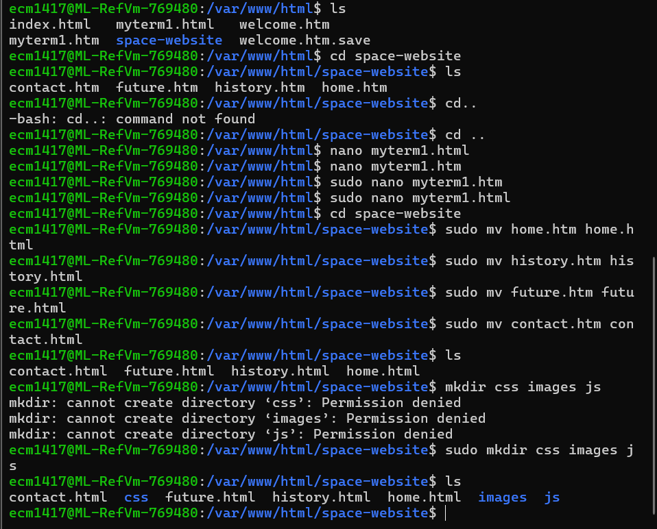
File initial Setup
Entry 2 – Week 2 (Page Completion & Enhancements)
Date | 5 February 2026
Time | 19:00 – 21:30
Duration | 2 hours 30 minutes
Description | Implemented the core layout and styling for all pages using CSS. Applied a consistent colour scheme with a blue navigation bar and structured typography using the Arial font family. Developed the History page milestone layout and began constructing the Future page vertical timeline using Flexbox and CSS positioning. Implemented hover effects on navigation links and images to improve interactivity. Resolved spacing and alignment inconsistencies across different screen sizes.
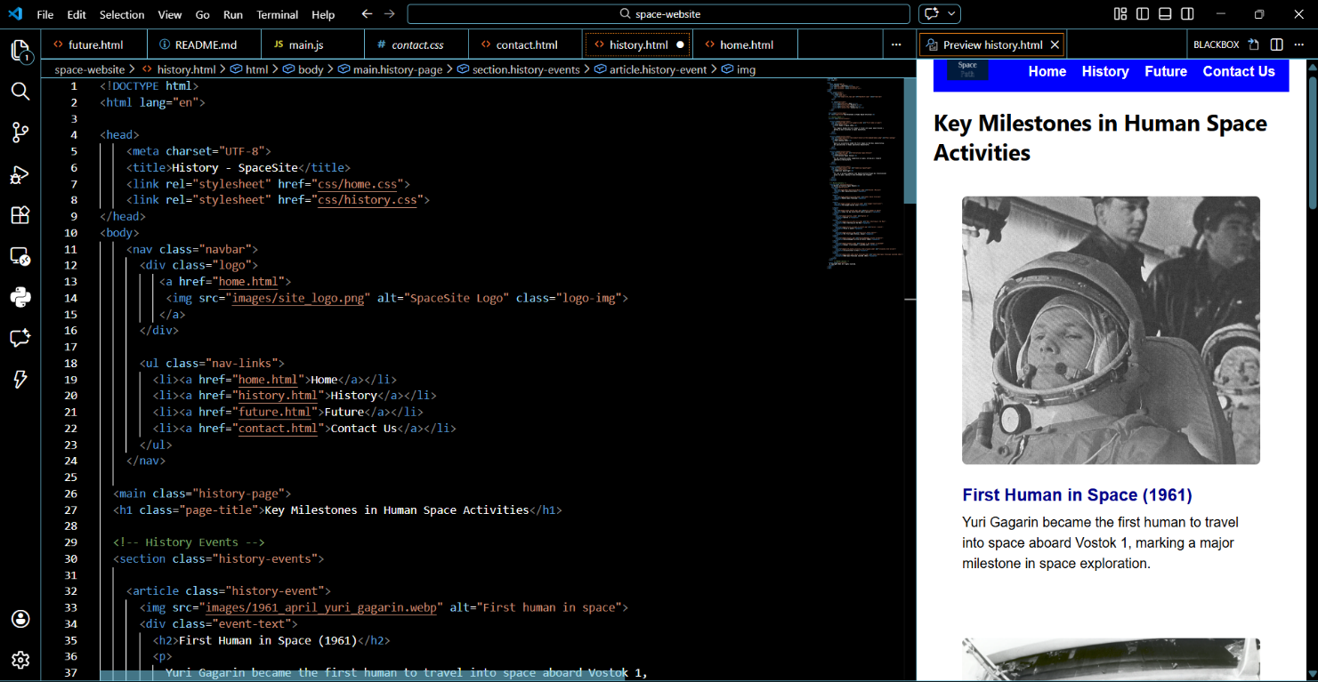
Entry 3 – Week 2 (Branding )
Date | 9 February 2026
Time | 17:45 – 20:00
Duration | 2 hours 15 minutes
Description | Designed and integrated a custom website logo using Canva to replace the placeholder text logo. Added high-quality space-related images to meet the 4×3 gallery grid requirement on the History page. Refined hover scale effects and adjusted overflow settings to prevent layout shifting. Conducted cross-page consistency checks to ensure navigation and branding remained uniform.
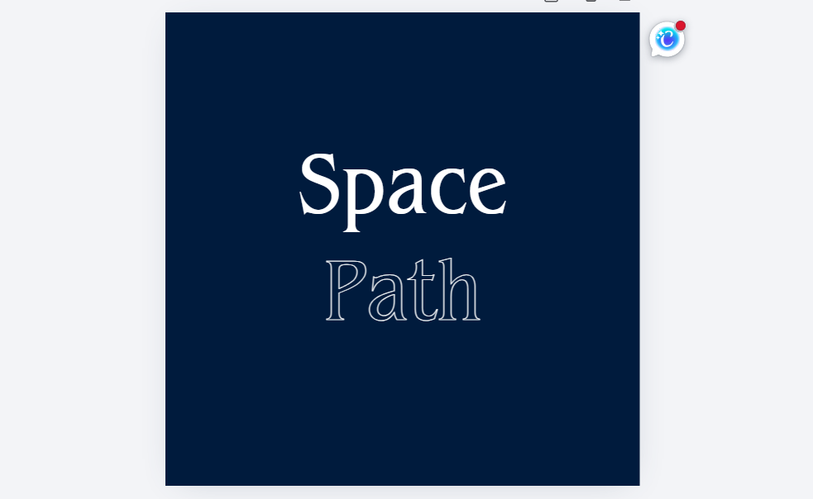
Entry 4 – Week 3 (Deployment & Debugging)
Date | 15 February 2026
Time | 16:00 – 19:00
Duration | 3 hours
Description | Deployed the website to the virtual machine environment and performed systematic testing across all pages. Identified broken file paths and corrected relative directory references for CSS, JavaScript, and image assets. Verified that navigation links functioned correctly after deployment. Tested form validation behaviour and confirmed compatibility in the VM environment. Refined minor layout inconsistencies and ensured all specification requirements were fully satisfied before final submission.
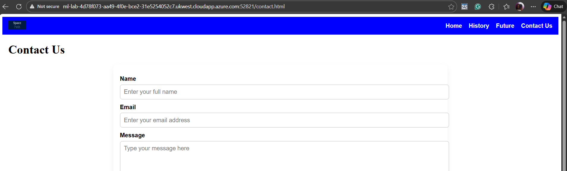

AI Declaration
Artifical Intelligence was used soley for grammar checking in this report.

